**Website’s landing page design.**

Landing page design includes:

* Banner
* About us section
* Program section
* Contact us section

**Programs page**

This page shows all the listed programs that can be added by students only if registered.

**Has the following functions:**

* View no. of enrolled students per program
* Add program button (can add the program only when student has account/registered)
* Program description once title is viewed.

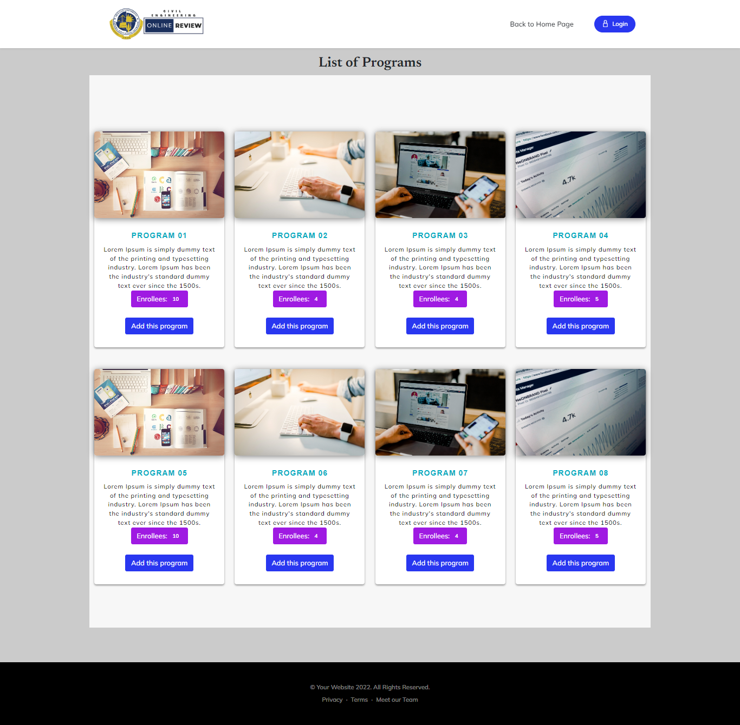

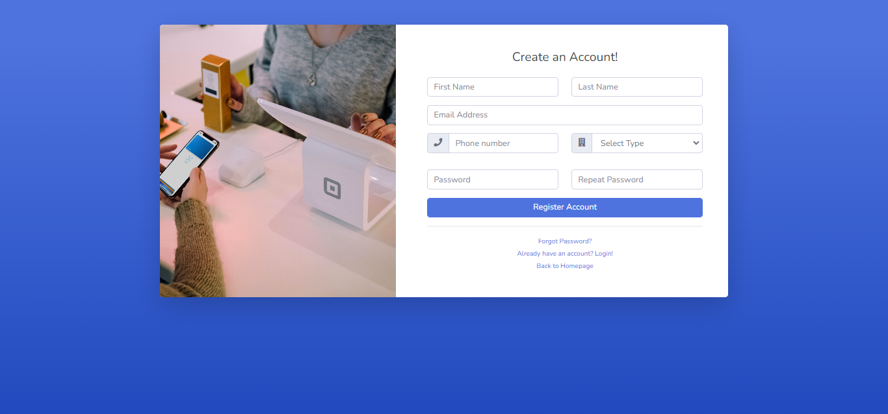

**Registration page**

* Who can register on the website?
  + Students
  + Professor (Admin)

**Login Page**

* + Only user who is registered can only access the dashboard page through login.

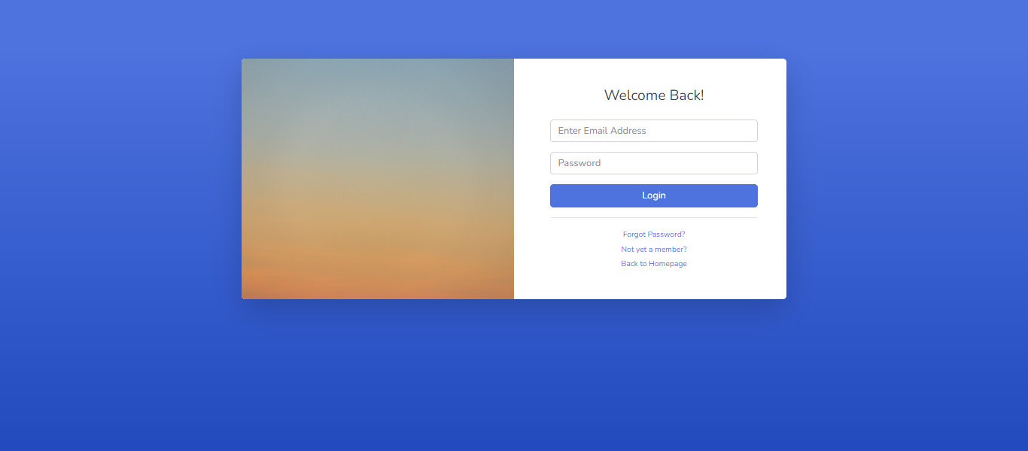

**STUDENT DASHBOARD**

**Dashboard page**

* + User’s dashboard when the user type is Student
  + Menus are the following:
    - My Profile, My Programs, My Exams, My Scores, and Settings
    - User has Activity log page

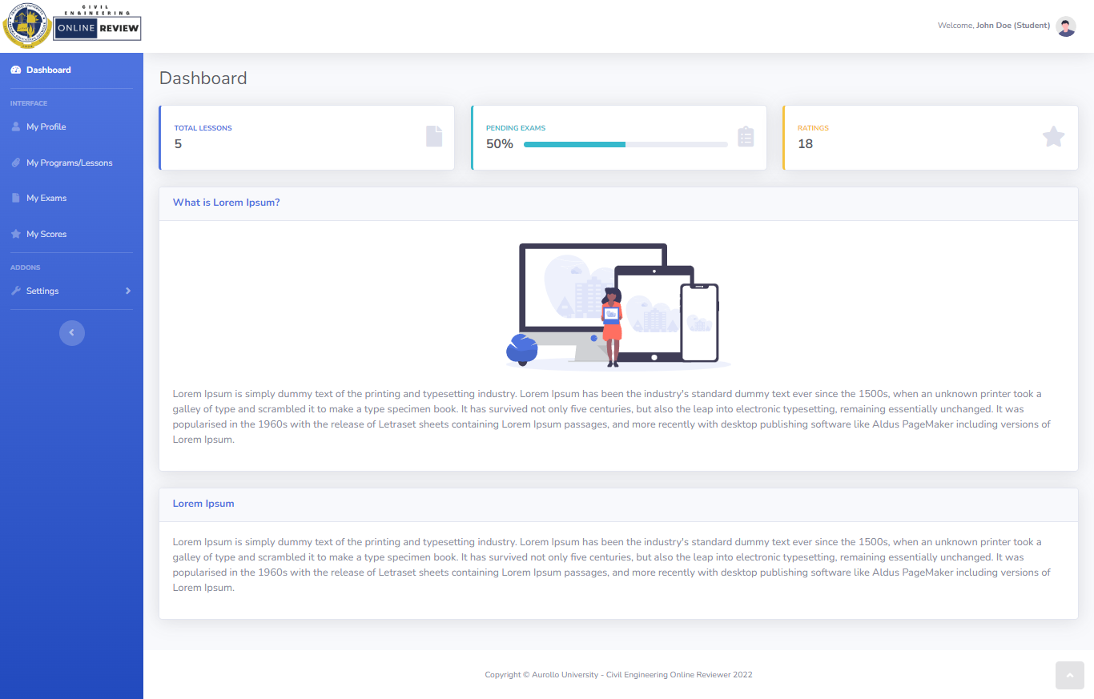

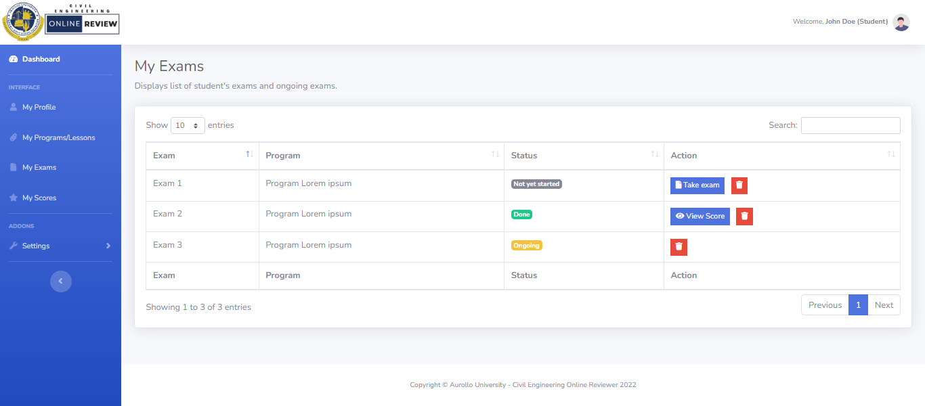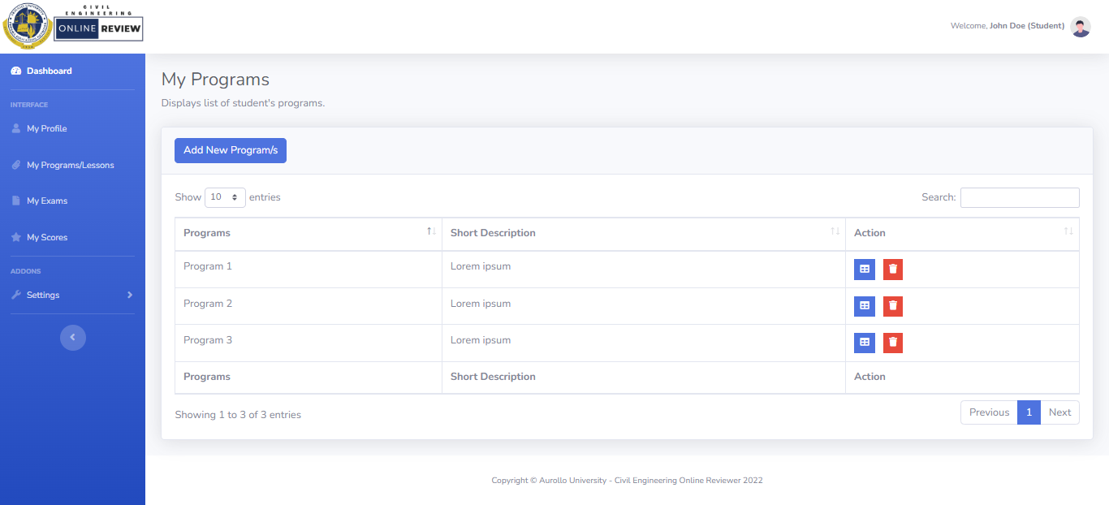

**My Exams page**

* + - Display’s list of exams already taken/to be taken by the student
    - When the student has not taken the exam, he/she can take the exam by clicking the ‘Take Exam’ button from the action column
    - This page shows if the exam has already been taken and he/she can view the score by clicking the ‘View Score’ button from the action column.
    - Students can delete the exam by clicking the ‘Delete’ icon from the action column

**My Programs page**

* + - Display’s list of programs added by the student.
    - Students can view the program description by clicking the view icon button from the action column.
    - Students can also delete the program by clicking the delete icon button from the action column
    - Students can add a new program by clicking the ‘New program’ button, which the students will select from the form the list of programs that they want to be added.

**My Scores page**

* + - Display’s list of student’s exam scores.
    - Can view the summary of score per exam by clicking the view icon from the action column list.

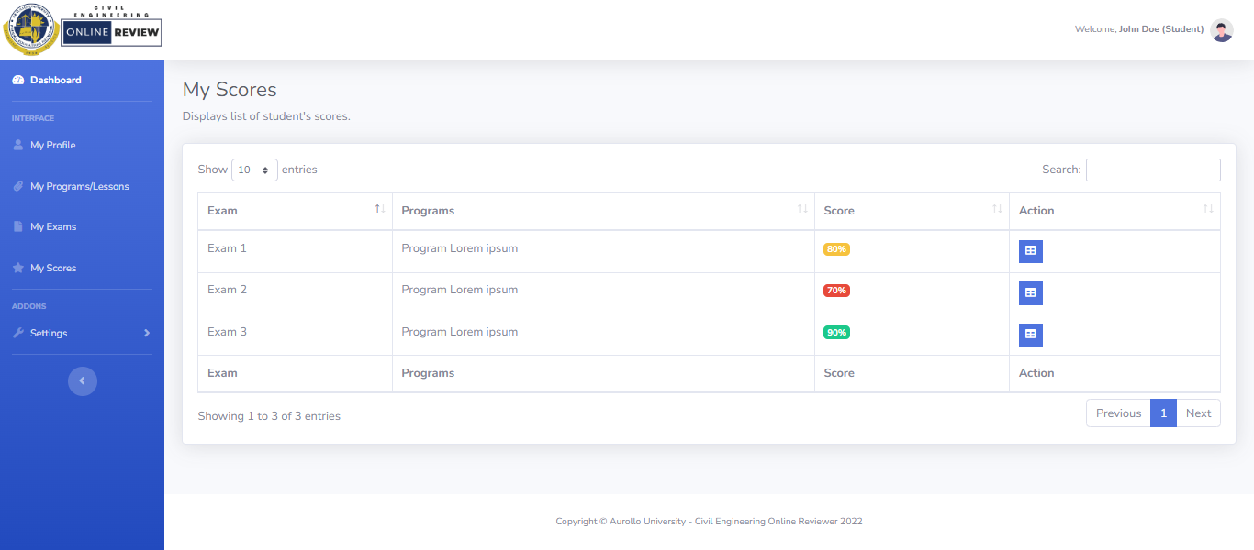

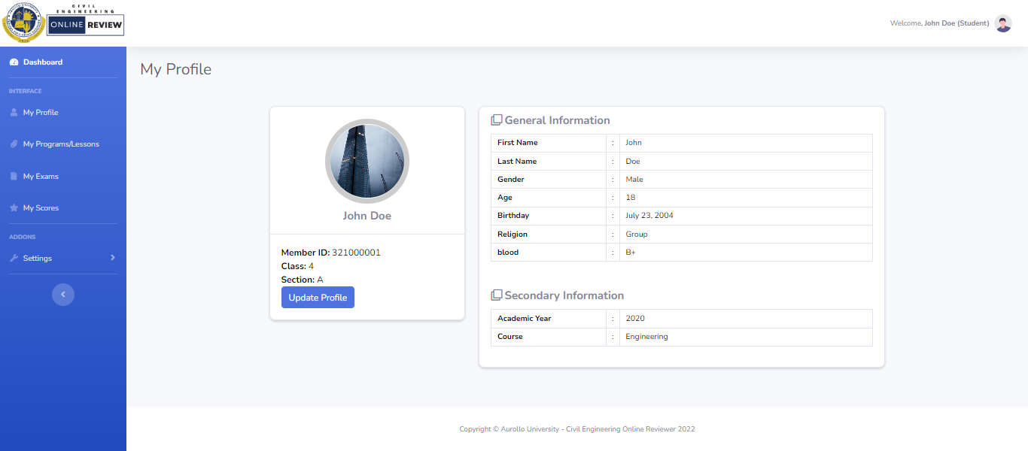

**My Profile page**

* + - Displays student’s profile
    - Can also update the student information by clicking the ‘Update Profile’ button

**PROFESSOR/ADMIN DASHBOARD**

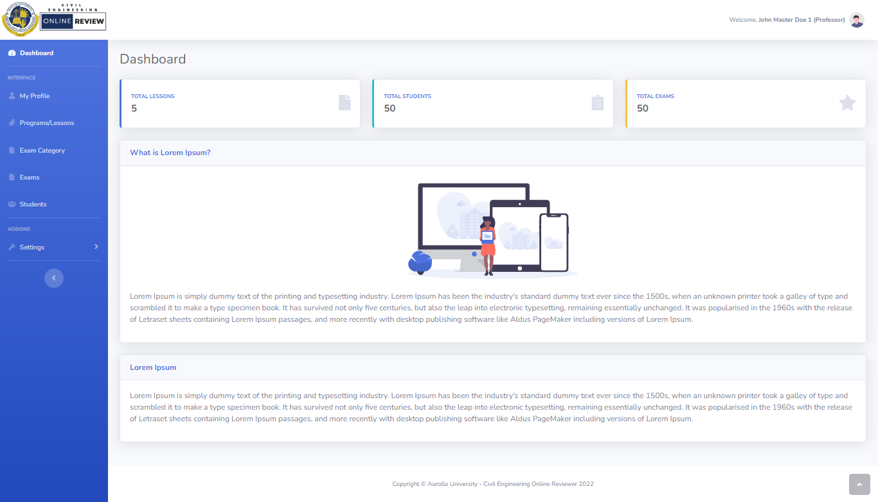

**Dashboard page**

* + User’s dashboard when the user type is Professor (Admin)
  + Menus are the following:
    - My Profile, Programs/Lessons, Exams, Exam Category, Students, and Settings
    - User has Activity log page

**Programs page**

* + Displays list of programs
  + Displays no. of enrolled students for each program.
  + Admin/Prof can add, edit, delete and view the programs details.

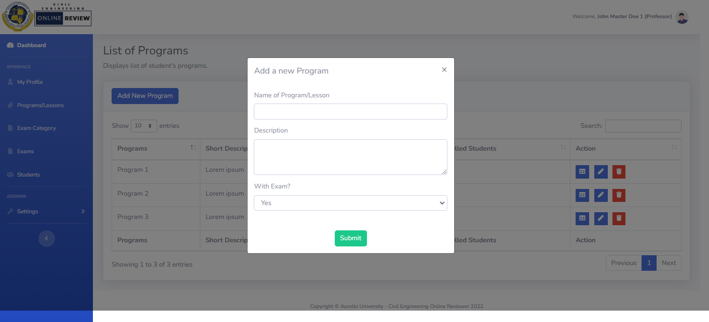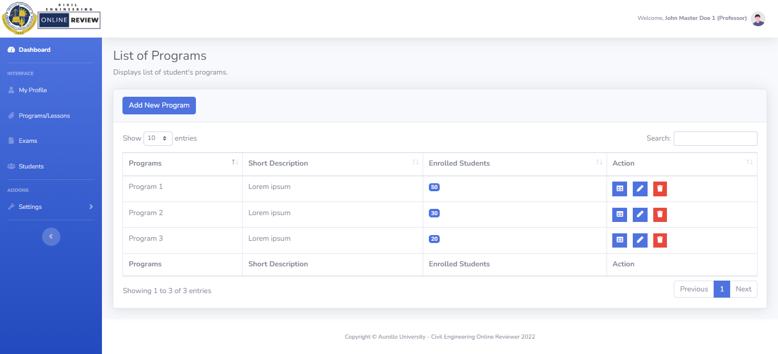

**Pop-up modal: Add program page form**

**Exams page**

* + Displays list of exams
  + Displays no. of students who take the exam.
  + Admin/Prof can view the list of students who take the exam for each program.
  + Admin can add, edit, and delete the exam

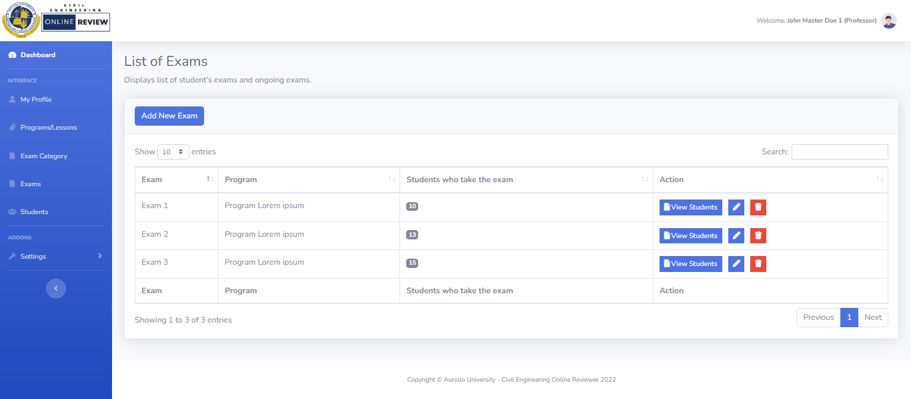

**Pop-up modal: Add exam page form**

**Exam Category page**

* + Displays list of exam category
  + Admin can add, edit, and delete the exam category

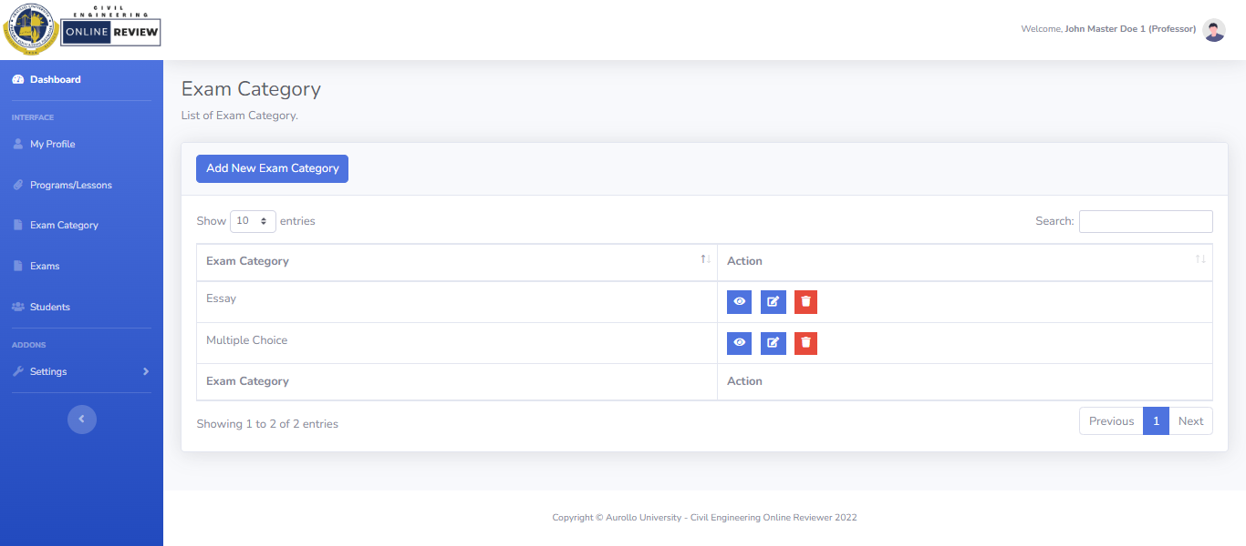

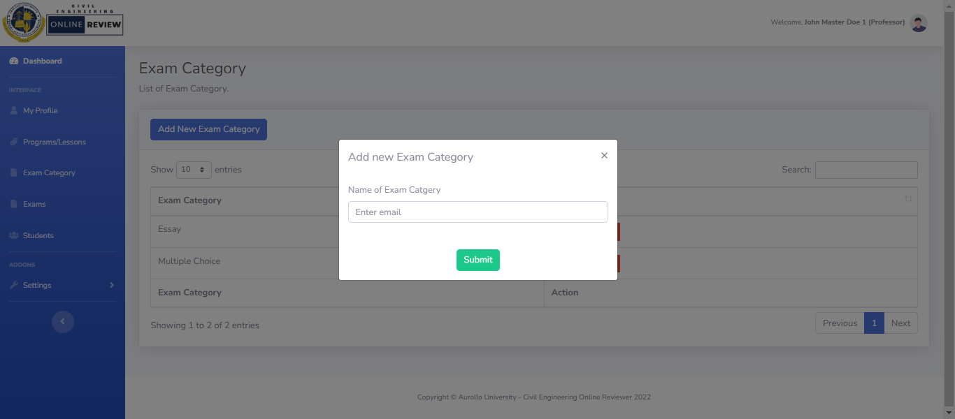

**Pop-up modal: Add exam category page form**

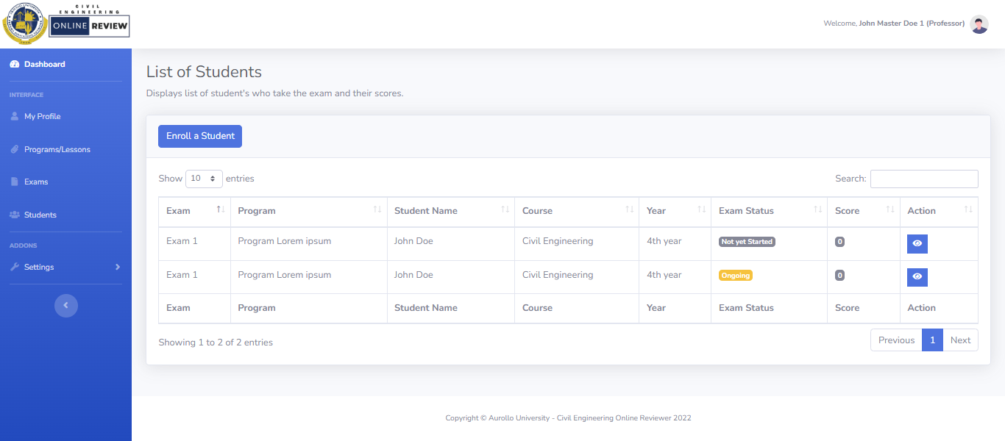

**Profile page**

* + Displays admin’s profile
  + Can also update the student information by clicking the ‘Update Profile’ button

**Students page**

* + Displays list of students for each program
  + Display the student’s exam score
  + Displays the summary of student information, exam taken, and each exam’s score
  + Admin can enroll a student and choose a program for that student.

